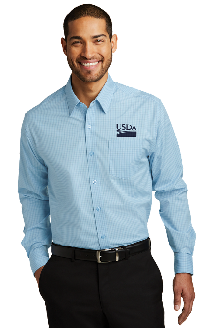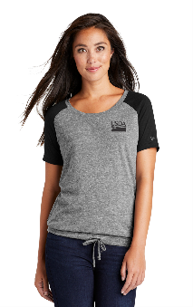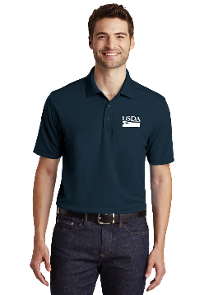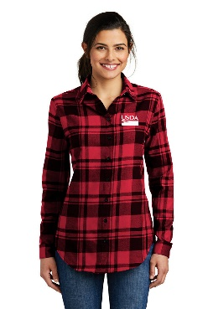

Emblem Report
March 14, 2019

How many times this week have you said, “I have nothing to wear to work?” Maybe you need more variety in your wardrobe or maybe you need a whole new wardrobe for work. I’ll just throw out there that Administrative Professionals Day is April 24. Perhaps an emblem item for your staff member to show your appreciation? Well, I have just the right solution for you, no matter what you’re looking for. You can now stock your closet with USDA & NASCOE attire or find that perfect gift and help build the NASCOE Scholarship fund. Each purchase from the emblem store will contribute 15% to the NASCOE Scholarship fund. This weekend you can support scholarships and stock up your closet by visiting the NASCOE store. Our emblem supplier, Superior, will be on hand with a wide variety of USDA and NASCOE items and can be found in the Humanities Room. If you can’t find what you need you can visit the NASCOE emblems store online at https://nascoe.org/store and order that special item. Superior will ship items straight to your door! Hesitant to order online? Don’t be. If you don’t like what you ordered, or sizing isn’t just right simply return your item for a full refund or exchange, minus shipping costs.
Be sure to check us out on Facebook at “Emblems by Superior.”

Respectfully submitted,
Sara Bateson
IASCOE Emblem Chair

