President’s Report
June 2018

Greetings Illinois IASCOE Members,
This report allows me another venue, affording me the opportunity to help others understand more about the organization that works so very hard for the FSA employees! I’d like to explain how getting involved can be a
member benefit. The Choice is Yours.

Do you know that a person makes over 70 decisions in an average day? Don’t you feel that it is important to be a part of the decisions that are being made which affect you directly?
Why is membership important and can we do some things better?
The short answer is: IASCOE/NASCOE works for your job benefits; Fighting to maintain the benefits that the organization has worked hard to achieve for its members; Fighting to get the employees of FSA even better benefits. For the employee who makes their career in FSA, there is strength in numbers when it comes to fighting; and of course, there is always room for improvement.

Now for the long answer. To be better informed, let me suggest that you attend a board meeting, one of our seasonal events, possibly the Midwest Rally (which, by the way, will be held in IL in March 2019), and especially our own State Convention, or take a big leap and go to the National Convention. The meetings and conventions are structured and are not “just a big party”. After business is reported on, covered with National and WDC dignitaries, discussed and questioned, there are activities planned, after business hours, that are fun and help you develop friendships and Agency acquaintances, not only from within your own state but also from across the United States. These contacts can be very beneficial, even in your daily work. You meet people with similar job duties, and who work under similar circumstances. It’s great to bounce ideas off each other, providing a network of supporters/contacts to make each and every day at work unique and, in the end, making you a better, more educated employee, not to mention the great friendships you can have. Let’s face it, on the job training is a lot of where we learn our techniques and fine tune our service to the farmers and ranchers of America. The point here is that it is directly through your IASCOE Association, that you have these opportunities. However, if you don’t get involved, you are missing out.

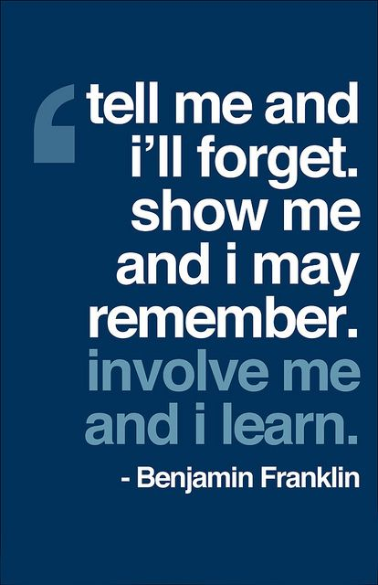
I know this does not answer all your questions, but this is a good place to start. We have several committees that you can get involved with. Please remember that most of what we do must be done after hours and on the weekends. Contact your IASCOE Director and ask for the Summary of Committees Sheet (they all have a copy) so that you can check it out and plug in somewhere.

So, again, The Choice is yours. What will you choose, to be a part of a good and beneficial work or to sit by and let the chips fall where they may?

